PSAT Score Report Review

PSAT Essential Questions
• How can you assess skills, understand your academic needs, and make sense of your interests from this score report?
• How can you use your scores to predict future performance on the literature EOC?

After reviewing your scores, look to the bottom of your report at Improve Your Skills. Under each section (Reading, Writing and Language), you will find hints for improving specific skills. These hints have been tailored to your individual performance.

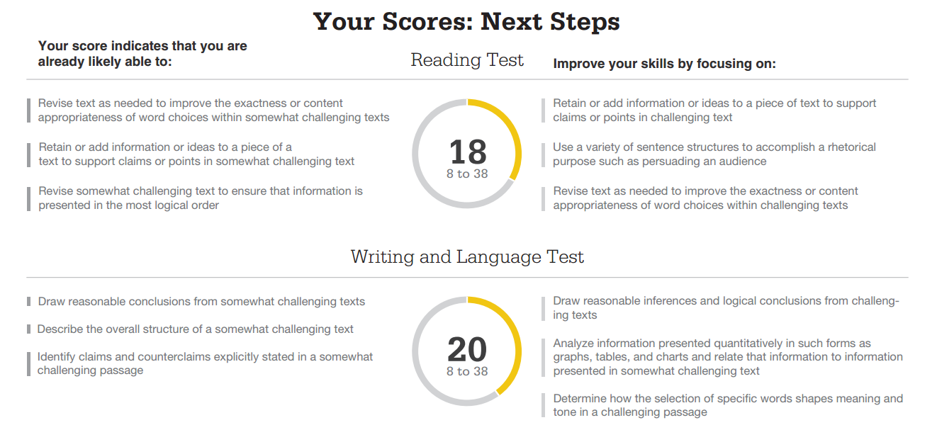

Next, look at the questions you missed. Beside the Subscore Code below, tally the number of questions you missed of each.
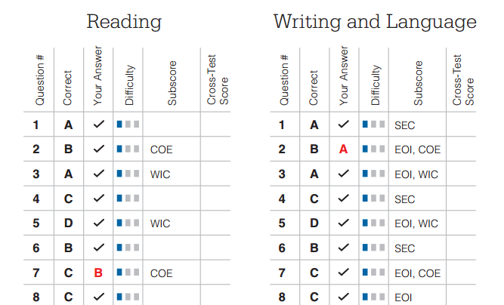

COE (Command of Evidence) _______________________________________________

WIC (Words in Context) ___________________________________________________

EOI (Expressions of Ideas) __________________________________________________
SEC (Standard English Conventions) _________________________________________

After reading the improvement suggestions and tallying the subscores of your missed questions, make a statement about your goals for the semester.

Reading Test:
Complete this statement:
I struggle with ____________________________________________________ because

_____________________________________________________________________.

I plan to _____________________________________in order to improve this semester.

Writing and Language Test:
Complete this weakness statement:
I struggle with __________________________________________________ because

_____________________________________________________________________.

I plan to _____________________________________in order to improve this semester.

PSAT Score Report Review
Extra Credit

Step 1: Get your PSAT access code on your Score Report.
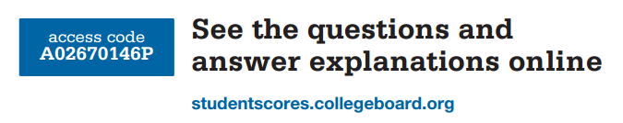

Step 2: Go to khanacademy.org/sat.
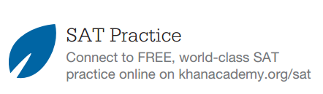

Step 3: Complete one Reading Test and one Writing and Language Test.

Step 4: Print the score reports for the two tests.

Step 5: Write a comparison paragraph that explains the relationship between your online practice test and your PSAT report.

