Greek Theater

The Greek Actor
Participating in Greek drama was considered to be a citizen's civic duty. Citizens were expected to volunteer to perform in the chorus. Experienced performers, especially citizens trained in oratory, were elevated to the status of actor. The Greek actor, who might also be a governmental official or influential businessman, was highly regarded in Greek society. So revered, the actor was often exempted from military duty.
In this male-dominated society, women were not allowed to act. They were often excluded from the audience, or when allowed to attend, were relegated to the upper rows of seats.
The actor portraying the god, king, or legendary hero needed to appear larger than life. As a symbol, he reflected a grander status than mere mortals, like those appearing in the chorus. He needed to be seen by the audience who were at a great distance from the stage. Therefore, the actor donned a costume which added size and distinction to his role.
The actor wore a long, flowing robe, dyed in symbolic colors, called a chiton, with a great deal of padding underneath to give a broader than natural appearance. To add height, high, platformed shoes called cothurni were worn.
Though the actor gained in size, he lost mobility, which led to a more declamatory style of acting which required the actor to move little and to face his audience for delivery of his speeches. Because of distance from the audience and limited mobility, actors developed stock, broad, sweeping gestures and general movements which signified particular emotions, such as lowering the head to indicate grief, or beating the breast and rending their clothes to indicate mourning, or stretching out arms in prayer.
Actors carried properties (props) to indicate roles. A herald might wear a wreath, a traveler a broad-brimmed hat. Kings customarily carried scepters and warriors carried spears. The elderly carried sticks serving as canes.
The most distinctive feature of the actor's costume was the mask. Paradoxically, the mask both limited and broadened the audience's understanding of the role portrayed. The mask helped to identify the specific character, yet generalized the features enough to indicate a virtual Everyman, helping the audience to glean that personal message the Greeks intended to impart in their drama.

The Mask
Born of man's use of the mask in religious ritual to inspire awe in the congregation by appearing more than mortal and to hide his face from the gods as he impersonated them, the theatre adopted the mask as one of its more significant conventions. To complete the larger-than-life picture, the actor wore a large mask which served both as a megaphone with its large aperture for the mouth, and as a symbol to distinguish the role. It identified age, sex, mood, and rank. Fully hooded, it rested on the shoulders of the actor. Usually the mask was constructed of bark. cork, leather, or linen. The most beautiful were tragic; the grotesque and bizarre depicting creatures like frogs and birds were reserved for comedy. The flexibility of changing masks allowed actors to change roles easily. A mask was called a persona.

Tragic Mask Comic Mask Greek Dramatic Masks
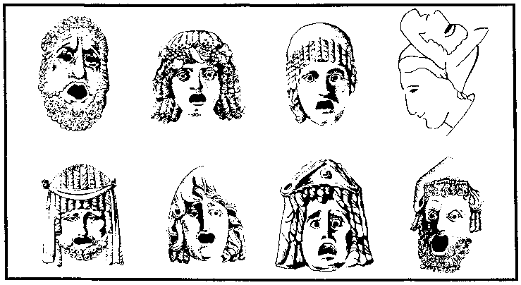

The Role of the Chorus

Characteristics of the Greek chorus:
- Group of approximately 15 men
- Sang lyric poetry and danced to musical accompaniment
- Were unpaid, drawn from the citizenry at large
- Performing in the chorus was regarded as a civic duty
- Were trained and costumed
- Wore the dress of the people they represented and wore light masks

Functions of the Greek chorus:
- Provided link from audience to actors, responding to the play in a manner the playwright hoped the audience would respond—the ideal spectator
- Provided tension release
- Reflected upon what has happened, pondered what might happen, asked questions
- At times advised central characters
- Often functioned as the conscience of the people, establishing an ethical perception from which to view the action
- Helped to establish mood and to heighten the dramatic moments through movement and song
- Added theatricality to performance
- Helped to establish important pacing of the play, pointing moments at which the audience should reflect upon what has occurred and what must yet transpire
- Could be in the play or outside of it, by either participating in the action or by commenting on the action as merely an observer
- Separated scene of action from one another
- Usually through a leader as spokesperson, could interact with the central characters

Movements of the Greek chorus:
- Choral songs were divided into stanzas: strophe (turn), antistrophe (turn the other way), and epode (added song). These were sung while the chorus moved (danced).
- While singing the strophe an ancient commentator tells us they moved from left to right.
- While singing the antistrophe they moved from right to left.

Phyllis Hartnoll, The Concise History of Theater (New York: 1969, Harry N. Abrams, Inc. ) 19.
George R. Kernoodle, Invitation to the Theatre, (New York: 1967, Harcourt, Brace and World, Inc.) 163.
© COPYRIGHT, The Center for Learning. Used with permission. Not for resale.

