Sharing Google Documents (Files)
(http://drive.google.com)
Adapted from “The Paperless Classroom with Google Docs” by Eric Curts

Overview

Google Drive (Google Docs) provides a way for us to “go paperless” through sharing and collaboration options. This guide will help you set up a shared folder and create documents in Google Drive so that we can limit our consumption of paper and enjoy the benefits of communication outside of the classroom. By sharing documents, presentations, etc., you will enable me to provide feedback, notes, suggestions, and such. You will receive emails as I comment on your work, which will allow you to make necessary revisions prior to final due dates.

If you already have a Gmail account, you do not need to set up a new Google Account to use Google Drive. You will simply need to log in to Gmail and add Google Drive to your account. If you do not have a Gmail account, you can create a Google Drive only account with an email address you already own.

Kevin Murtha’s YouTube video provides simple instructions for setting up a Google Drive account. View this video at https://www.youtube.com/watch?v=0Sv9ocaRXB8

How to create a shared folder

I would like for you to share documents with me as soon as you create them. Please be sure to give me permission to edit the document so that I may add comments. You should begin by creating a shared folder.
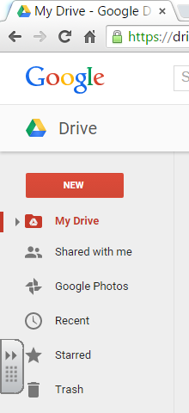

- In your Google Drive, click “NEW” to bring up a menu for creating folders or files or uploading existing files. Click “FOLDER+” to bring up a dialog box where you can name the folder.
- Name the folder HWL S17 Lastname Firstname. (Example: HWL S17 Smith Ralph)
- To share the folder you must first open the newly created folder, then click on the person with a + in the top right corner.
- This will open the Sharing settings window.
- At the bottom of the window there will be a box labeled Add people:
- Click in that box and type my email address: ms.vanbo@gmail.com.
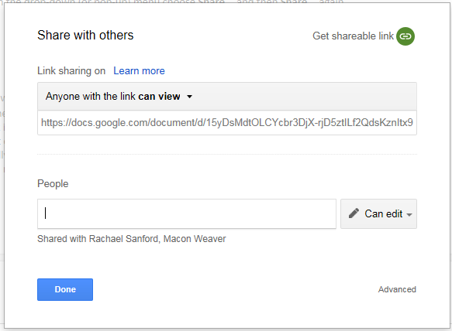
- Next click the Can edit button to enable me to edit or comment on or view the file. Finally, click the Save & share button.
- I will receive an email message indicating that your folder has been shared with me, and every file you place in that folder will automatically be shared with me.

If you prefer to use OneDrive, simply follow the same instructions for creating a folder, naming it, and sharing it with me.

